Assignment No. 8
(SAMPLE FORMAT)
Distributed System Mini Project Report Multilayer Ludo King Game using GUI Application

SUBMITTED BY
Name 1(seat no)
Name 2(seat no)
Name 3(seat no)
Name 4(seat no)

UNDER THE GUIDANCE OF
Prof. Shubhangi Wadibhasme


Department Of Information Technology Zeal Education Society’s
ZEAL COLLEGE OF ENGINEERING AND RESEARCH , PUNE-41, (2025-26)

INDEX

- INTRODUCTION

- PROBLEM STATEMENT

- OBJECTIVES

- IMPLEMENTATION

- RESULT
- CONCLUSION

INTRODUCTION :
Everyone must have once played a ludo game in their life. This is a board game. In this, there is a maximum of 4 players. Every player has 4 tokens. Players have to race their tokens and tokens have to reach the home again.
Every token is initially locked in the home. The player has to roll a dice and if one appears on the dice then the user can unlock one token
Every token has to start from home and take a round trip to reach its final state.
Each time player has to roll a dice and whatever number appears on the dice, the player has to move his token by that many steps. It’s his choice which token he wants to move.
If number 6 appears on the dice, then the player will get to roll the dice again. If 3 6s appear in a row, then the turn is forwarded to the next player.

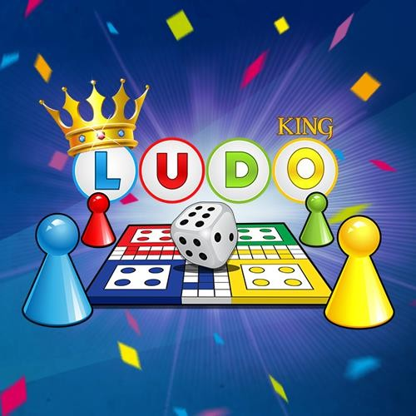

PROBLEM STATEMENT :
Develop a multiplayer Ludo King game using GUI Application to enable real-time gameplay and seamless communication between players.
Scope:
There is a splash screen with a ludo icon on it. This is a simple one-screen application. This is an offline application. There is a dice in the middle. Tap the dice to roll it. Whatever number appears on the dice, the player has to move any of his tokens by that step. The player whose all tokens finish from start to end wins the game.

Real-Time Connectivity and Seamless Experience :
At the heart of our multiplayer Ludo King game lies the power of GUI Application, enabling seamless real-time connectivity between players. The goal of the game is to move all four of the player's pieces clockwise once around the board, up the home column, and into the home triangle. To begin, a player must roll a six to move a piece out of the base and onto the start position. The gameplay experience is as smooth as it is immersive.

Community Engagement and Social Interaction :
In the ever-evolving landscape of digital gaming, one genre has stood the test of time and taken on a new life in the digital realm — Ludo. Once confined to family game nights and coffee shop tables, Ludo has undergone a transformation, thanks to the innovative realm of Ludo Game Development. In this blog post, we delve into the captivating role of Ludo Game Development Company in unleashing the potential of social gaming.

OBJECTIVES :

Start: Each player starts with four pieces in their respective starting area.

Movement: Players take turns rolling a die and moving their pieces accordingly.

Goal: The objective is to move all pieces from the starting area to the home area by exact dice rolls.

Blocking: Players can block opponents' pieces and send them back to their starting area.

Safe Zones: Certain spaces on the board are safe zones where pieces cannot be captured.

Winning: The first player to move all their pieces to the home area wins the game

IMPLEMENTATION :

Game Design: Define the rules and mechanics of Ludo King, including dice rolling, token movement, home column, safe squares, capturing opponent tokens, and winning conditions Determine the visual style, theme, and overall look and feel of the game.

Development Environment Setup: Choose a game development platform or framework such as Unity, Unreal Engine, or a mobile development framework like React Native or Flutter. Set up the development environment and tools needed for coding, testing, and debugging.

User Interface (UI) Design: Create UI mock ups and wireframes for the main menu, gameplay screen, settings, leaderboard, and other relevant interfaces.
Design intuitive and responsive UI elements for touch-based interactions on mobile devices or mouse/keyboard interactions on desktop platforms.

Game Mechanics Implementation: Write code to handle dice rolling mechanics, token movement, collision detection, and game logic for capturing opponent tokens and reaching the home column. Implement rules for safe squares, bonus moves, and other special conditions.
Ensure that the game mechanics are fair, balanced, and aligned with the original Ludo King rules.

Multiplayer Functionality: Integrate multiplayer functionality to allow players to compete against each other online. Implement matchmaking, lobby creation, and room management systems.
Set up real-time communication protocols for synchronizing game state between players and handling player actions.

AI Opponents (Optional): Develop AI opponents with varying difficulty levels for single-player mode or to fill empty slots in multiplayer games.
Implement AI algorithms for decision-making, token movement, and strategic planning.

Graphics and Animation: Create or acquire graphical assets such as board layout, tokens, dice, and visual effects. Implement animations for dice rolling, token movement, capturing opponent tokens, and other game events to enhance the overall gaming experience.
Implement audio cues for dice rolling, token movement, capturing opponent tokens, and other gameplay events.
Testing and Debugging: Conduct thorough testing to identify and fix bugs, glitches, and performance issues. Test the game on different devices and screen sizes to ensure compatibility and responsiveness.

Deployment: Prepare the game for distribution on app stores (Google Play Store, Apple App Store) or other platforms (Steam, web).
Create promotional materials such as screenshots, trailers, and descriptions to attract players. Publish the game and monitor user feedback for further improvements and updates
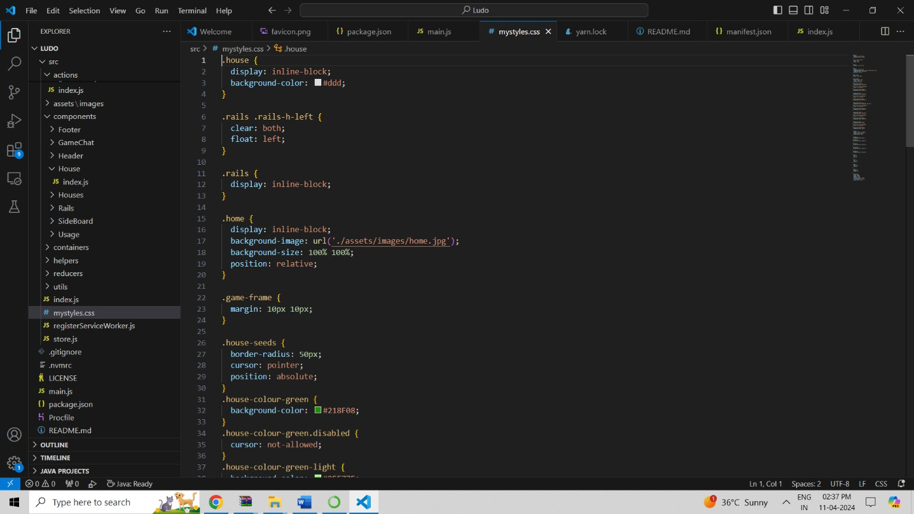
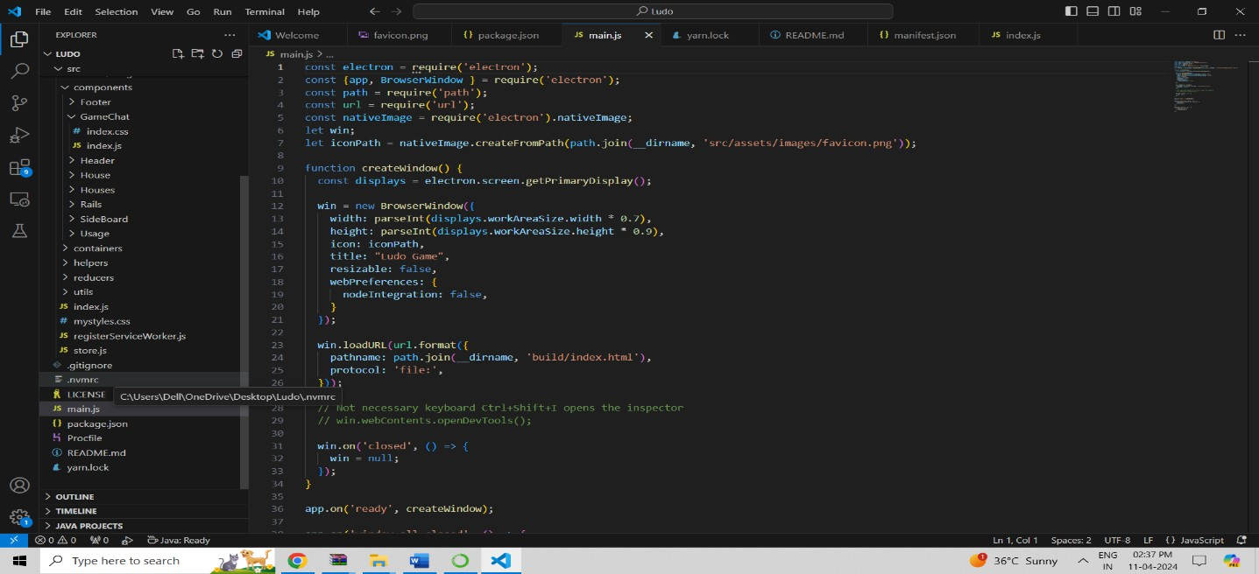
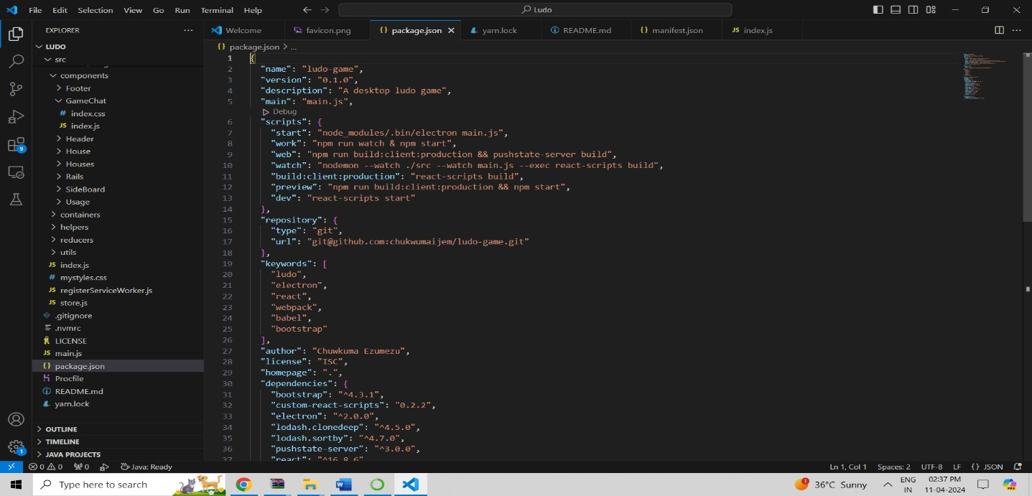
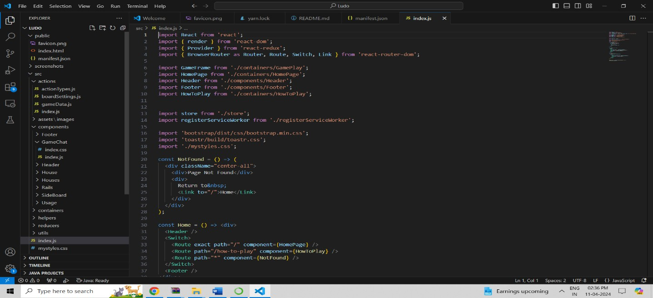

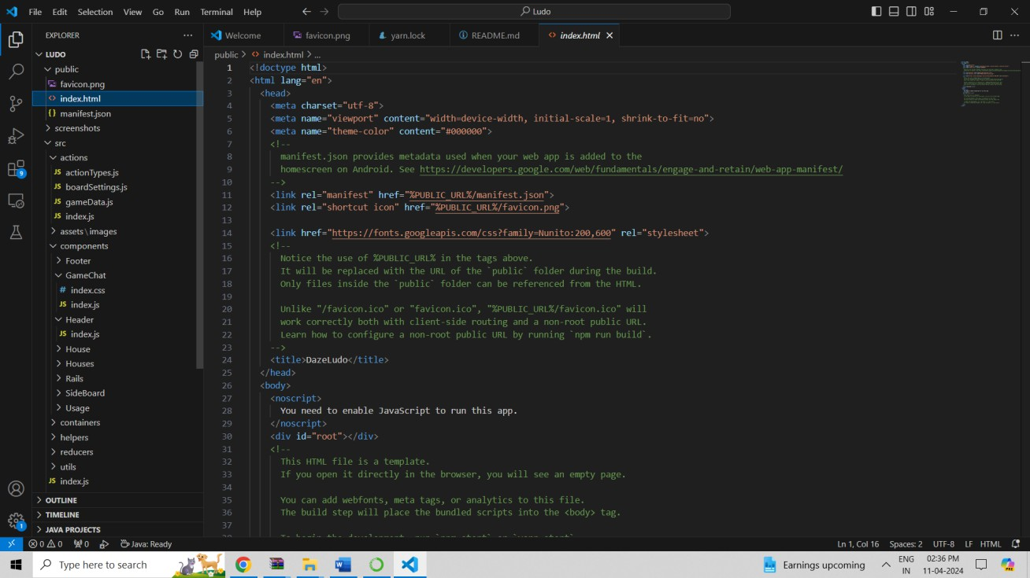

RESULT :

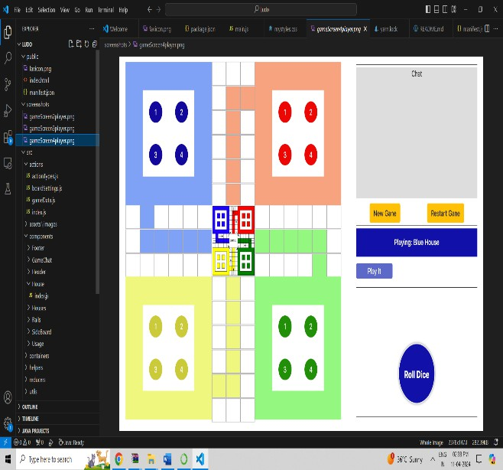
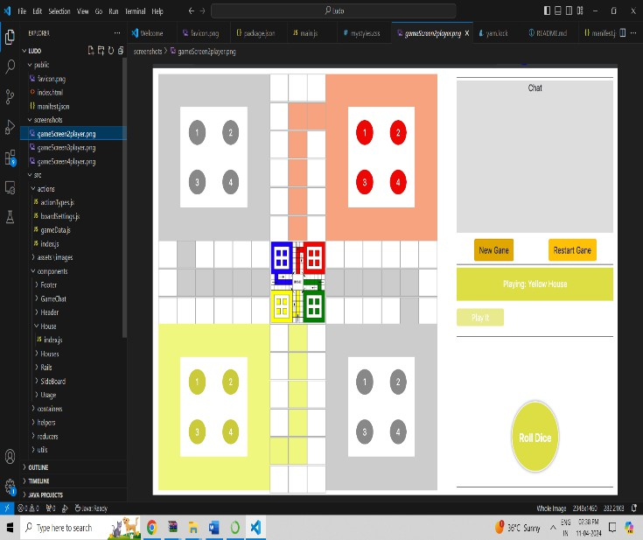

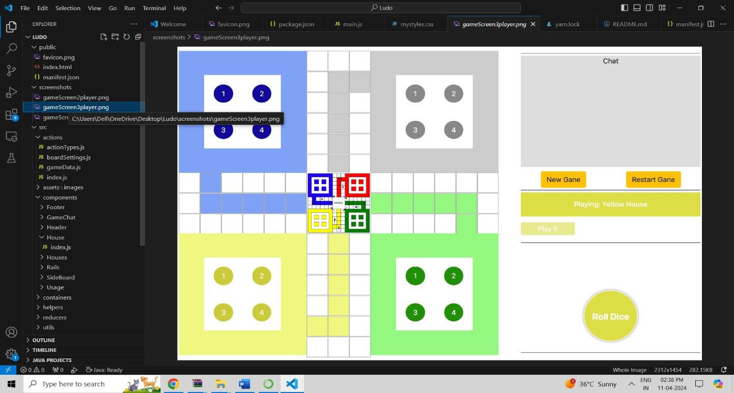

CONCLUSION :
The success of a Ludo game lies in its ability to entertain players, foster social interactions, and evoke a sense of nostalgia while offering fresh and exciting gameplay experiences. With careful planning, creativity, and attention to detail, developers can create a Ludo game that captivates audiences and stands the test of time in the ever-evolving landscape of digital gaming.

REFERENCES :

  - "Search for a trade mark – Intellectual Property Office". www.ipo.gov.uk. Archived from the original on 1 April 2012. Retrieved 30 December 2009.
  - "History". Archived from the original on 4 November 2008. Retrieved 30 December 2009.
  - "How to play Trouble | Official Rules | UltraBoardGames". www.ultraboardgames.com.
Retrieved 2021-10-22.
  - Murray (1978), p. 138.

